
Student Full Name
Nicolas Anibal Pizarro Puebla
Student Number
2026491
Module Title
Statistical Techniques for Data Analysis
Assessment Tittle
C1 - Bike Sharing Analysis

Lecturer/Supervisor
Taufique Ahmed
Assessment Due Date
01-11-2026
Date of Submission
01-11-2026

Contenido
1) Introduction: 3
2) Dataset Overview and Data Quality 3
3) Descriptive Statistics and Visual Analysis 4
4) Binomial Analisis 7
5) Poisson Analysis 10
6) Normal Analysis 13
7) Comparison of Distributions and Conclusion 14
8) References 15
9) AI Use Appendix 16
A1 16
A2 17
A3 18
A4 19
A5 20
A6 21
A7 22

Introduction:
in this report, I analyse the Uci Bike Sharing dataset (Fanaee-T,2013). The objective is to describe rentals patterns and evaluate how probability distributions can help you answer questions about the data. Descriptive statistics and visualizations are used to examine rentals by hour, variability and possible outliers. Binomial and Poisson are applied to working day records at 17:00 while a Normal model is explored using normalised temperature. All statistical analysis is carried out in python using Jupyter notebook, with attention to model assumptions and limitations

Dataset Overview and Data Quality
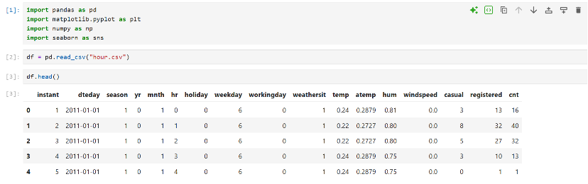
Load the dataset by hour and inspect its structure using Head, info, and shape. The data contains 17,379 records and 17 columns. It doesn’t have missing or duplicate data. Use descriptive statistics to examine the center, the range of rentals per hour, and dispersion.

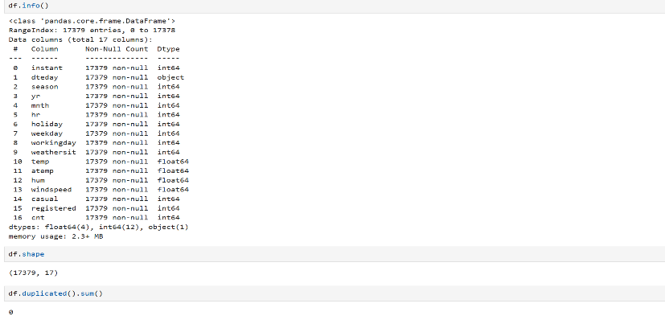

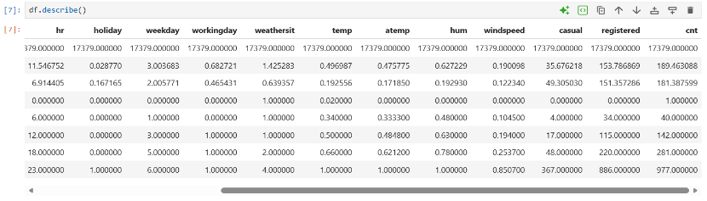

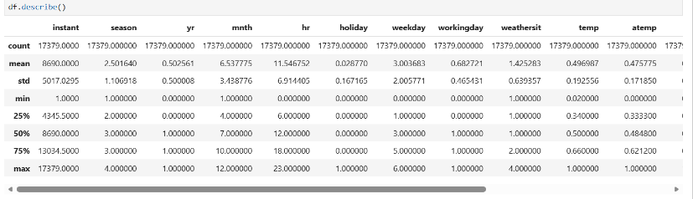

Descriptive Statistics and Visual Analysis
I decided to work with “cnt” since my idea is to describe the number of rentals per hour. There are 17379 records, the mean is 189.46 compared to a median of 142, which indicate that there is a skew toward higher values. We have a standard deviation of 181.39, which reflects considerable variation. The central 50% of records is between 40 and 281 rentals. With a minimum of 1 and a maximum of 977
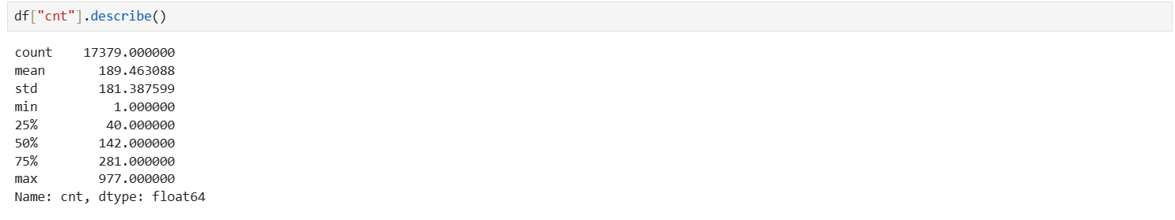

Interquartile Range and potential outlier:
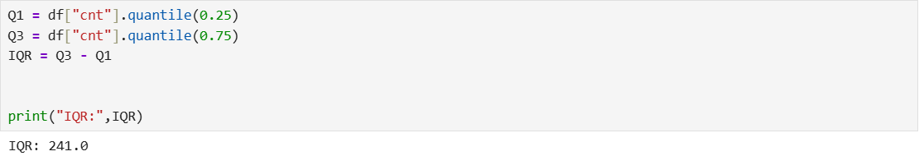
The IQR is 241 rentals and represents the width of the box, from Q1=40 to Q3=281

Identify possible outliers the 1.5 x IQR rule (Statistics Using the Revenues Column, n.d). I got a lower limit of -321,5 and an upper limit of 642,5. Since rents are positive counts, the possible outliers correspond to records with 643 rent or more
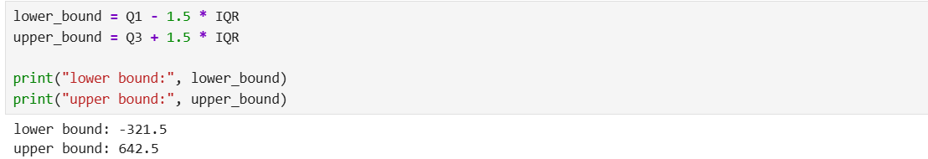

Identified 505 records that exceed the upper limit; this represents hours with a high number of rentals (they are not deleted since it does not mean they are errors)
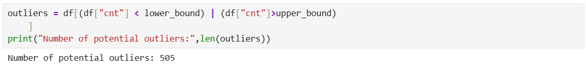

The highest hourly rental count was 977, recorded between 18:00 and 19:00 on 12 September 12. This gives me some context but did not establish the cause of the high demand
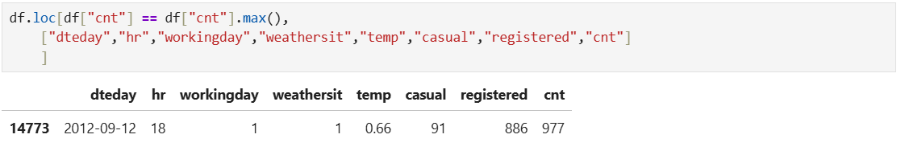

The boxplot suggests positive skewness, as the upper whisker is longer and outliers appear above it. I will create a histogram to look at the distribution of hourly bike rentals and find the most frequent rental range
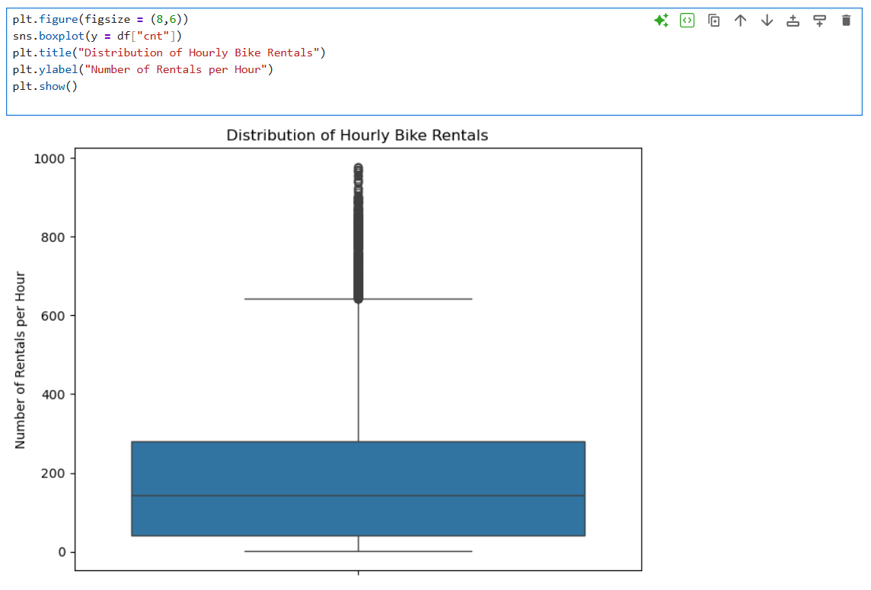

Distribution of Hourly Rentals:
Of the 17,379 hourly records, approximately 4,800 show between 1 and 50 rentals per hour, based on a visual estimate from the histogram. Hours with fewer rentals are more frequent than hours with higher rental counts. This is consistent with what the boxplot suggested: the distribution has a tail extending towards higher values and is therefore positively skewed.
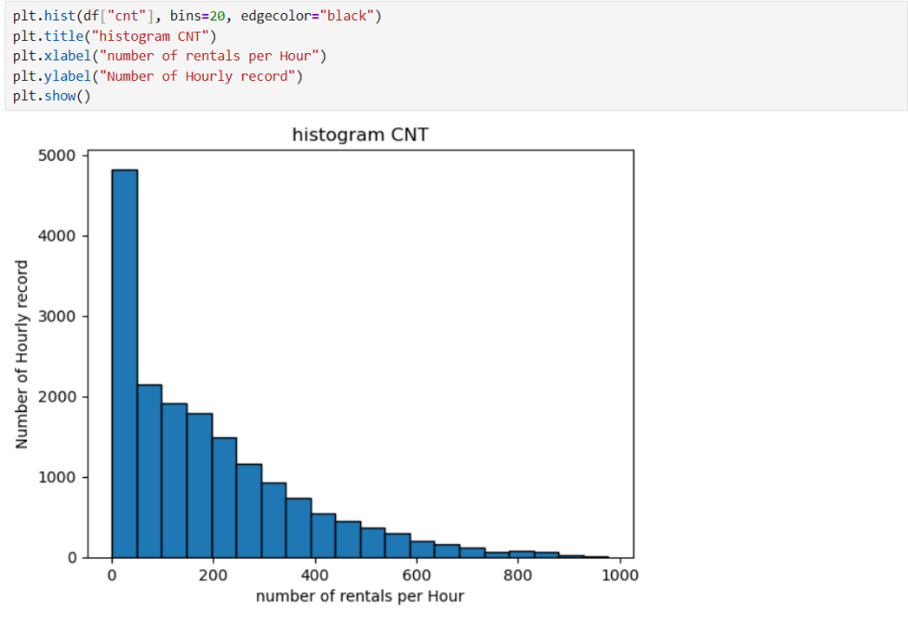

Average Rentals by Hour of the Day:
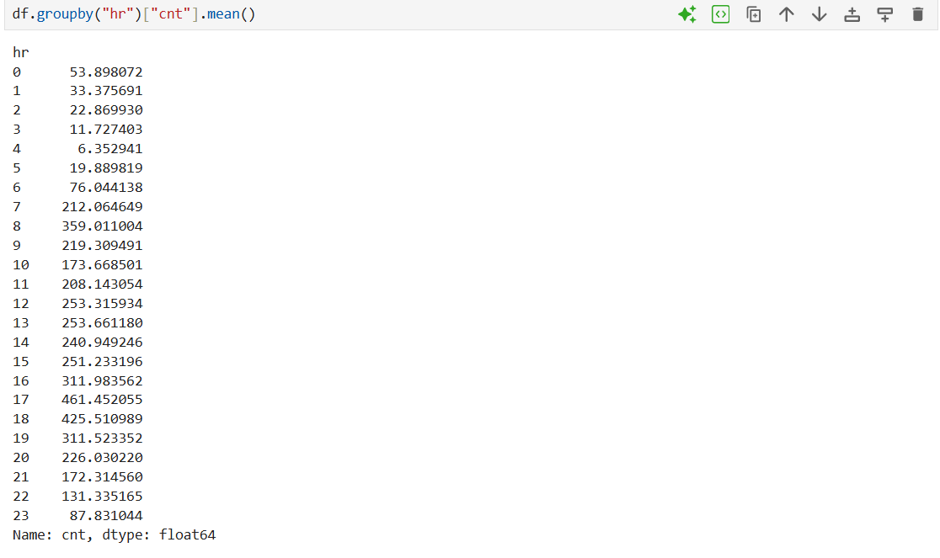
To analyze how demand varies throughout the day, I grouped the records by hour (hr) and calculated the average rentals (cnt) for each group. The result shows that a 17:00 it has the highest average, with approximately 461.45 rentals
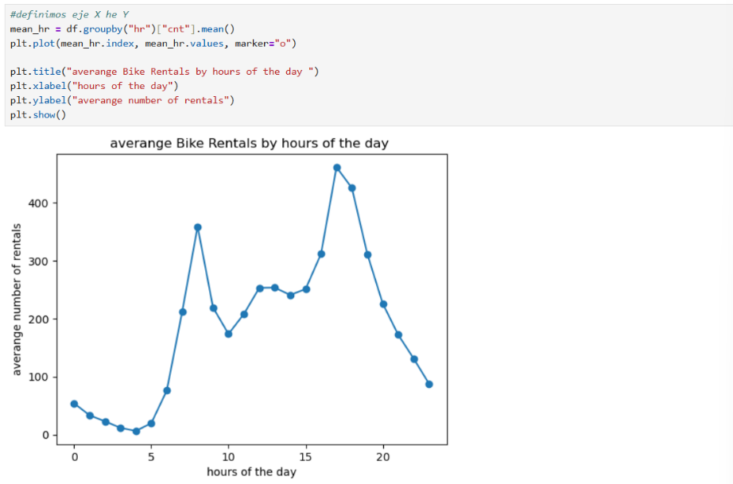

Mean rentals increased from 05:00, with a morning peak at 08:00 and the highest average at 17:00. These peaks may reflect commuting patterns, although the analysis does not establish their cause

Binomial Analysis
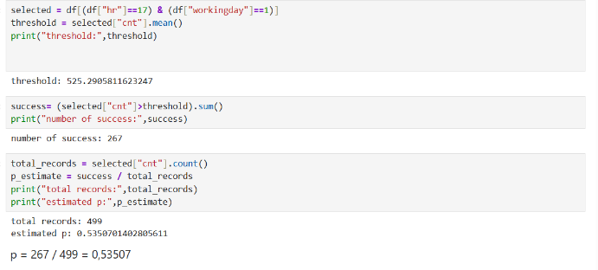
In 20 working days, what is the probability that at least 12 exceed the average number of rentals at 17:00?
Estimation of the Success Probability:
I selected working day records at 17:00 using hr==17 and workingday==1 according to the dataset dictionary workingday = 1 identifies days that are neither weekends nor holidays. their mean, 525.29 rentals, defined the threshold: 526 rentals or more represented success. Of the 499 selected records, 267 were successful, giving an estimated success probability of “P= 267/499 = 0.53507” (Probability Mass Function, Cumulative Distribution Function, n.d)

Binomial Probabilities and Interpretation:
to calculate the probability of getting at least 12 successful days out of 20, the data I used for my binomial distribution were:
n=20 attempts (days)
P=0.53507 coming from dividing number of successes/total records
K=number of successful days I’m interested in
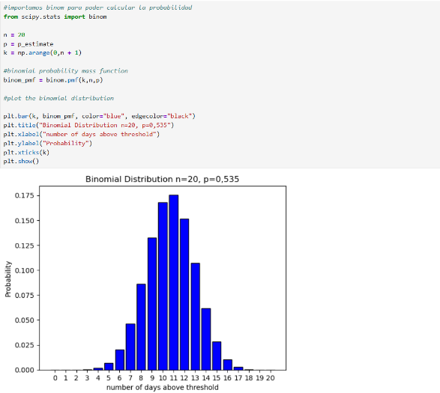

Using a binomial model with 20 trials and a success of probability of approximately 0.53507 the most likely outcome was to have 11 successes with a probability of 17.5% the probability of getting at least 12 successful days was calculated using binom.sf(11, n, p), which covers outcomes from 12 to 20 the result was 0.36245 or 36.25% according to the model’s assumptions
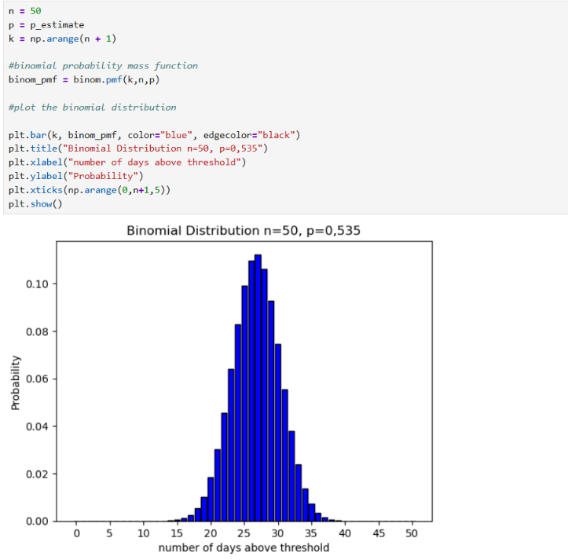
Effect of Increasing the Number of Trials

When comparing the distributions for 20 and 50 days, the results cluster around 11 and 27 successful days, respectively. This mean that considering more days increases the expected number of days that exceed the threshold, while the probability of success on each day stays constant at 53.5%. as the expected number of successes increases and p=0.535 is maintained, the shape become more approximately normal
Binomial Assumptions and Limitations:

assumption: in the binomial model (20 initial analyses and 50 comparison) we consider comparable working days. Each days has two possible outcomes: recording 526 rentals or more between 17:00 and 18:00 (success), or 525 or fewer during the same hour (failure). It is assumed that the day-to-day result are independent and that probability of success stays roughly constant at about 53.5% (Probability Mass Function, Cumulative Distribution Function, n.d)
limitation: picking working days at the same time doesn’t guarantee that these conditions are met. Weather season, and changes in demand can affect the probability or success, and nearby days might show related patterns. Also, this probability was estimated using 499 historical records so the result depends on the model’s assumptions and don’t guarantee what Will happen in another 20 or 50 days

Poisson Analysis
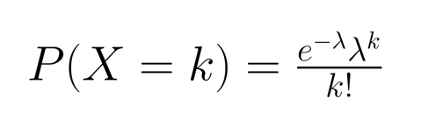
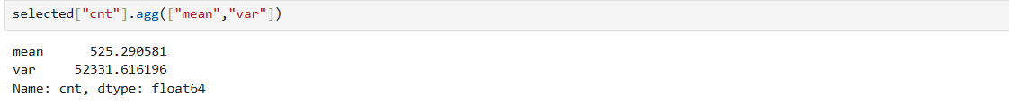
what is the probability of recording exactly 550 rentals between 17:00 and 18:00 on a work day?
source: Chugani(2024)
In a Poisson model, the theoretical mean and variance are both equal to lambda
I compared the observed mean of 525.29 with the variance of 52,331.62. the much large variance indicates overdispersion, suggesting that a simple Poisson model would underestimate the variability of hourly rentals
Poisson Probabilities and Interpretation:
I adapted the Poisson PMF plotting code from the class notebook (distribution_sept2025, n.d.).
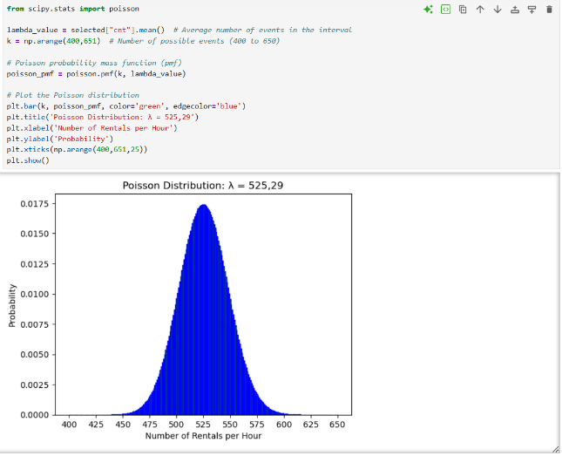

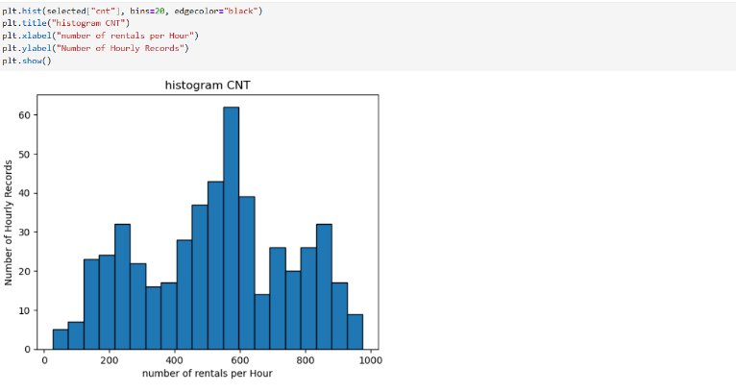
The probability of recording exactly 550 rentals between 17:00 and 18:00 on a working day is approximately 0.96% under the Poisson model. This result should be interpreted cautiously because the model underestimates the variability observed in the actual data
Comparison of Observed Counts and the Poisson Model:

the observed count ranges from just a few dozen to nearly 1,000 rentals, while the Poisson model concentrate its probability much more tightly around 525. The observed histogram also shows several peaks. This greater spread supports the overdispersion identified when comparing the mean and variance.
Effect of Lambda on the Poisson Distribution:
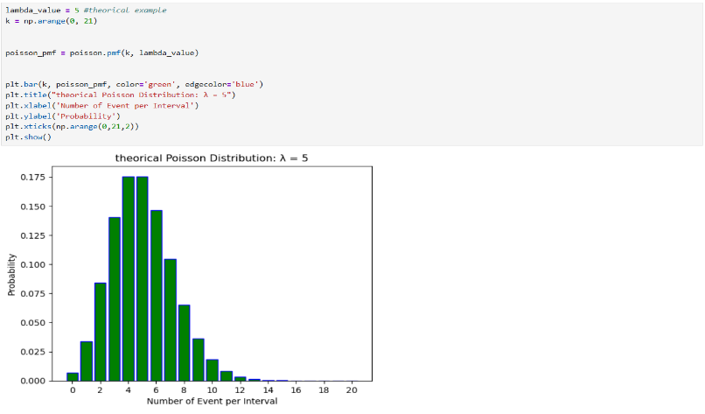

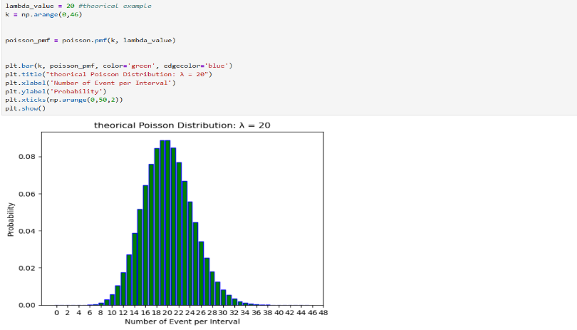

I decided to use smaller values of lambda to observe the differences between the graphs more clearly. With lambda =5, the distribution is right-skewed. With lambda=20, it becomes more symmetric, whereas with lambda 525.29, the Poisson distribution is approximately symmetric and its shape approaches the normal this comparison only changes the mean rate lambda, not the sample size, and it doesn’t eliminate the overdispersion observed in the real data
Effect of increasing the simulated sample Size:
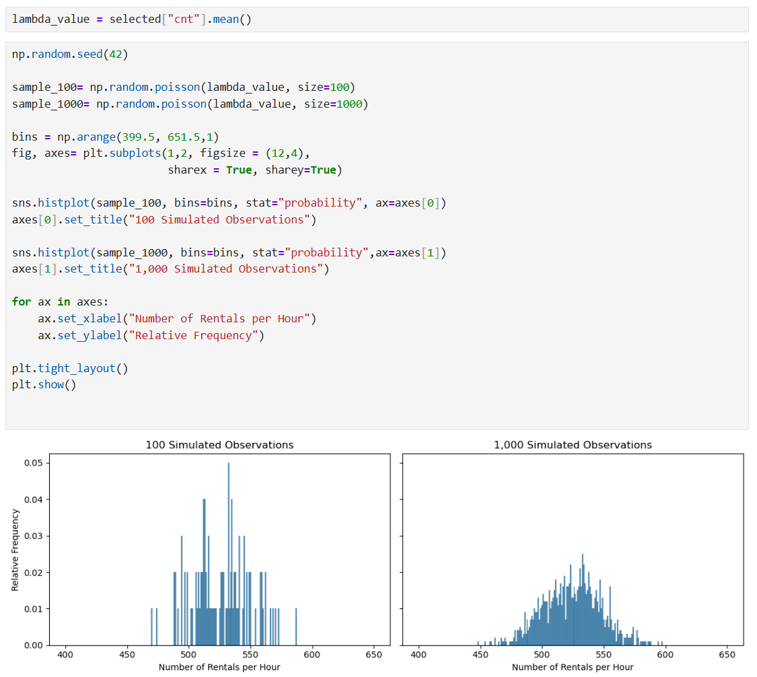

I Compare 100 and 1000 simulated observation keeping lambda constant 525.29. with 100 observations. The histogram showed irregular peaks and gaps. with 1000, Its shape was more regular and closer to the theoretical Poisson distribution. Relative frequencies tend to stabilise, as sample size increases but this does not eliminate overdispersion in the actual data.
Poisson assumptions and limitations:
selecting working day record at 17:00 makes the intervals more comparable. The Poisson model assume that rentals happen independently and at a constant rate, estimated here as lambda= 525.29 rentals per hour. However, demand may vary with weather and season. The observed overdispersion show that the model represent much less variability than the actual data

Normal Analysis
I will evaluate a normal model using the variable temp, a continuous temperature variable relevant to bike rentals. It is normalised on a scale from 0 to 1 so its values are not directly expressed in degrees Celsius (Fanaee- T,2013). I used a histogram and a Q-Q plot to assess if its distribution is approximately Normal (Normal Distribution, n.d.).
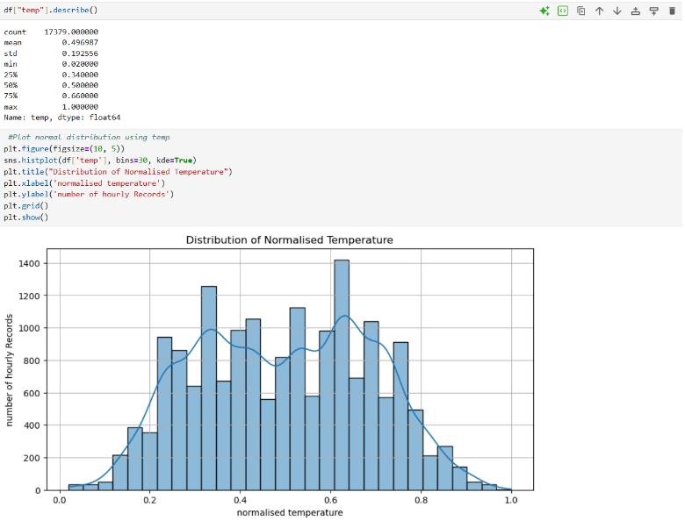

The temperature histogram showed two broad peaks around 0.35 and 0.65 rather than a single clear bell shape
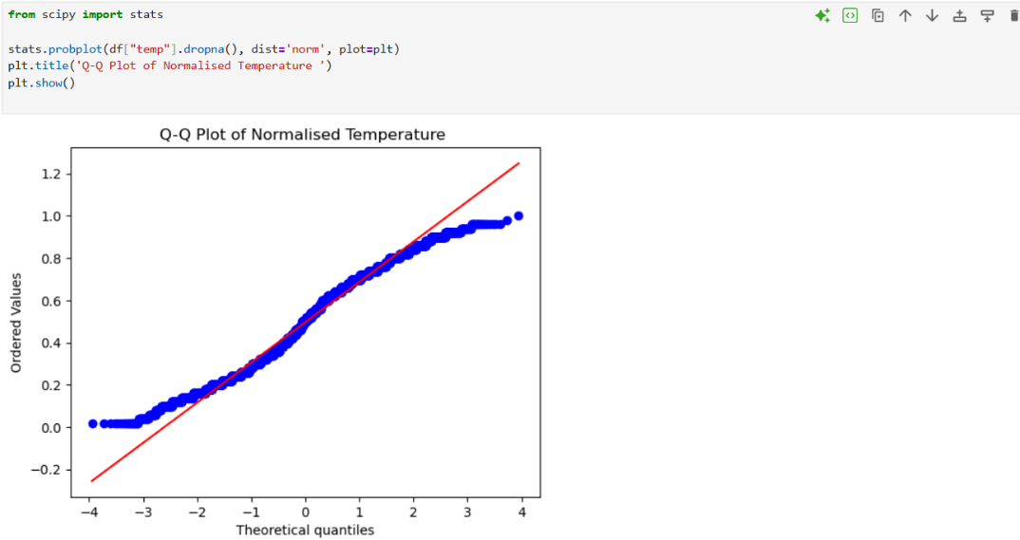

After examining the Q-Q plot, I notice that the points get close to the reference line in the central part but show clear deviation at the extremes. This indicates that the normal approximation has limitations, especially in the tails of distribution

Normal Probability and Observed Proportion:
under a normal model, what is the probability that normalised temperature fall between two chosen limits, and how does this compare with the proportion observed in the dataset?
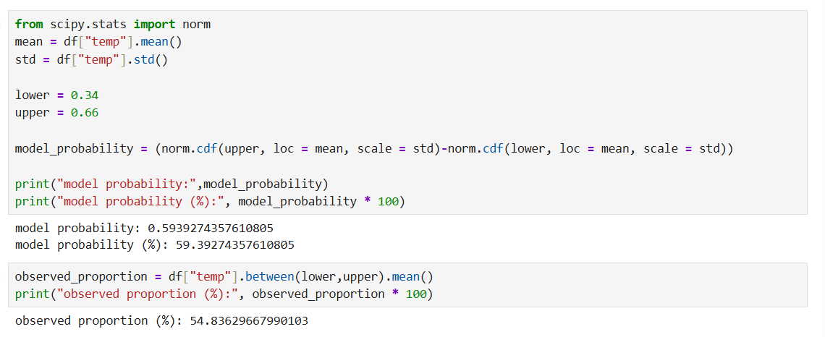
To answer my question, I will use my first and third quartile (Q1-Q3)

The normal model estimated a probability of 59.39% for normalised temperature between 0.34 and 0.66, compared so an observed proportion of 54.84%, so it overestimated the proportion by about 4.56 percentage point. This matches the deviation seen in the histogram and the Q-Q plot. The observed proportion is over 50% because values repeat at the quartile limits and both extremes were included

Comparison of Distributions and Conclusion
The three distributions allowed me to analyse different aspects of the dataset:
binomial modelled the number of days exceeding a threshold. Poisson modelled hourly rental count, and normal estimated probabilities for a temperature range. However, their usefulness depended on their assumptions and their ability to represent the data. Overdispersion limited the Poisson model, while the observed deviations in temperature limited the normal approximation. Binomial can be approximated by a Normal distribution when the expected numbers of successes and failures are sufficiently large, while Poisson approaches Normal when lambda is large, both remain discrete models. therefore, obtaining a theoretical probability is not enough: it is also necessary to assess whether the model reasonably represents the actual data.

References

Fanaee-T, H. (2013) Bike Sharing [Dataset]. UCI Machine Learning Repository. Available at: https://doi.org/10.24432/C5W894
Statistics Using the Revenues Column (n.d) [class handout]. CCT College Dublin.
Probability Mass Function, Cumulative Distribution Function (n.d) [Statistic handbook]. CCT College Dublin
Normal Distribution (n.d.) [Class handout]. CCT College Dublin.
Chungani, V. (2024) Poisson Distribution: A Comprehensive Guide. Data Camp. Avaliable at: Poisson Distribution: A Comprehensive Guide | DataCamp
Distribution_sept2025 (n.d.) [Jupyter Notebook]. CCT College Dublin.

AI Use Appendix
A1
AI Tool: ChatGPT
Date: 23-10-2026
Purpose: I needed panda codes to find the highest rental count and display related columns to examine its context
Exact Prompt and Relevant Output:

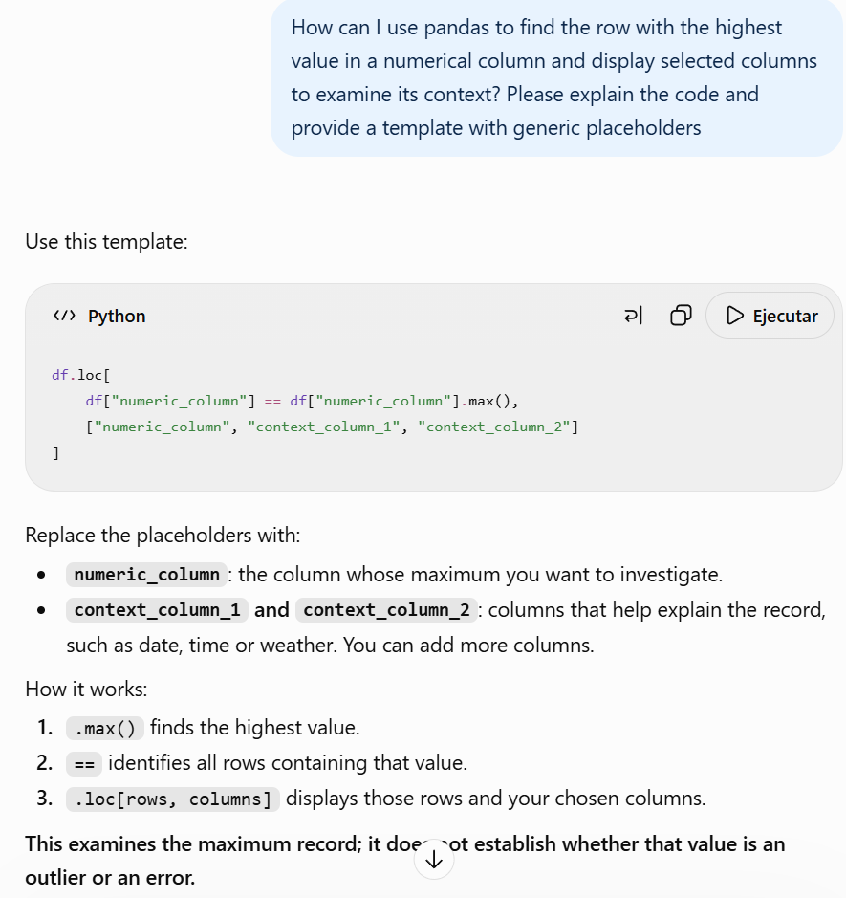
My evaluation and use:
I adapted the template to inspect the record with 977 rentals, including its date, hour and weather conditions, this helped me examine the maximum value, but did not prove whether it was an error

A2
AI Tool: ChatGPT
Date: 23-10-2026
Purpose: I want to know how to group records by hour and calculate mean rentals
Exact Prompt and Relevant Output:
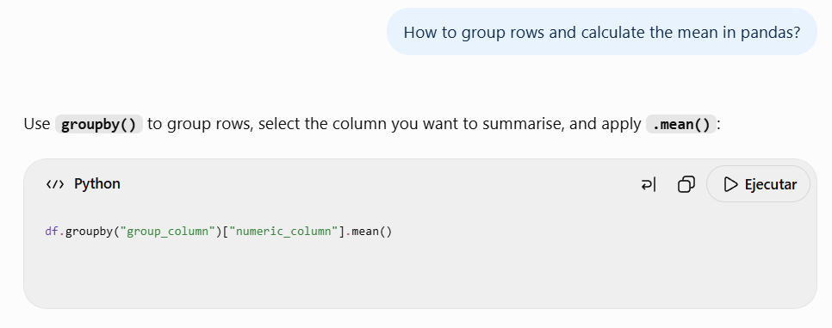
My evaluation and use:
I accepted this suggestion because it helped me group the records by hour (hr) and calculate the mean number of bike rentals (cnt) for each hour of the day.

A3
AI Tool: ChatGPT
date: 23-10-2026
purpose: I needed python code to calculate and compare the mean and variance
Exact Prompt and Relevant Output:
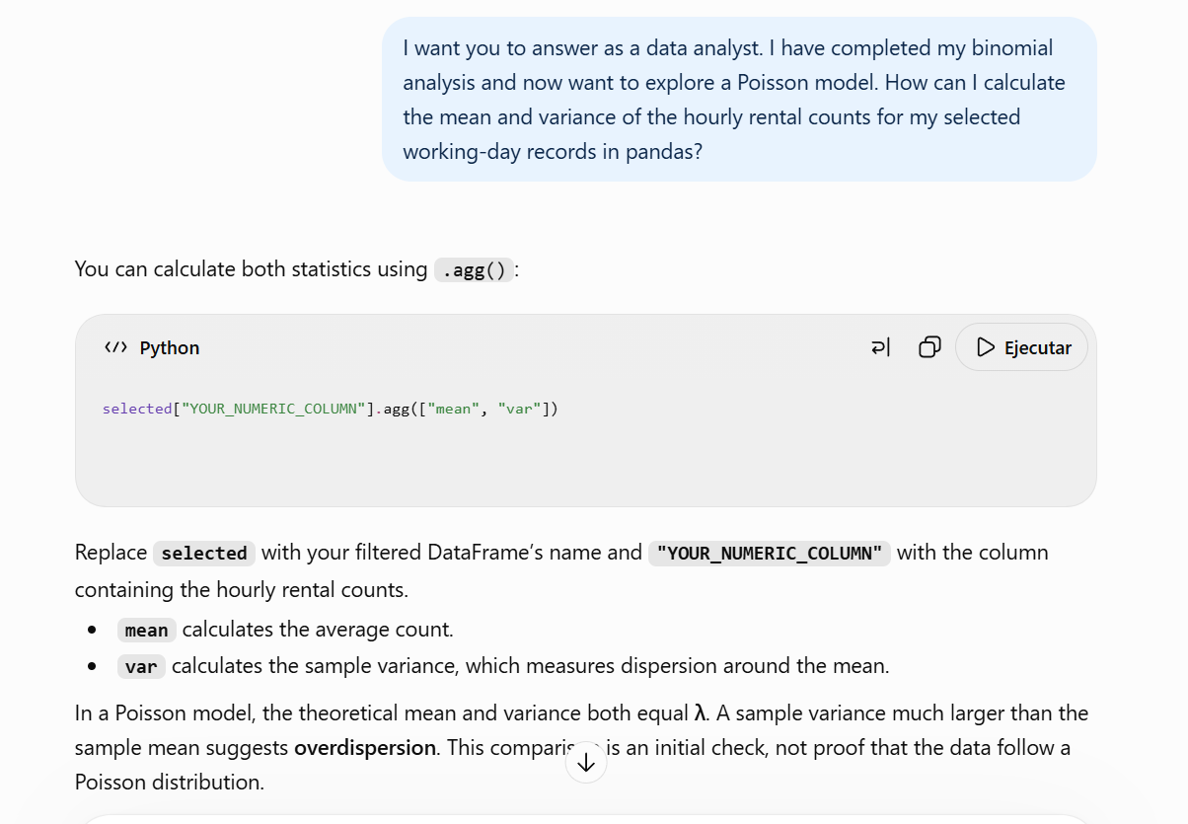
my evaluation and use:
this code help me how to calculate and compare the mean and variance before applying the Poisson model

A4
AI Tool:ChatGPT
date: 26-10-2026
purpose: I want to know how can I calculate threshold.
Exact Prompt and Relevant Output:
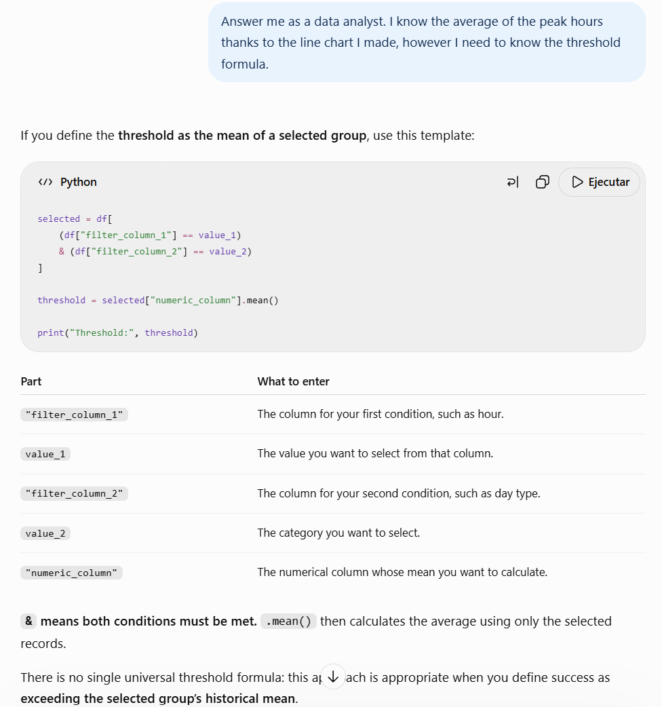
My evaluation and use:
I used the code to calculate the threshold because i could nor fine this specific filtering and calculation example in the distribution_sept2025 notebook. The explanation helped me understand which columns and values to use to select the records and calculate their mean

A5
AI Tool:ChatGPT
date: 28-10-2026
purpose: I needed help formulating a question that would allow me to apply normal and then evaluate its usefulness
Exact Prompt and Relevant Output:
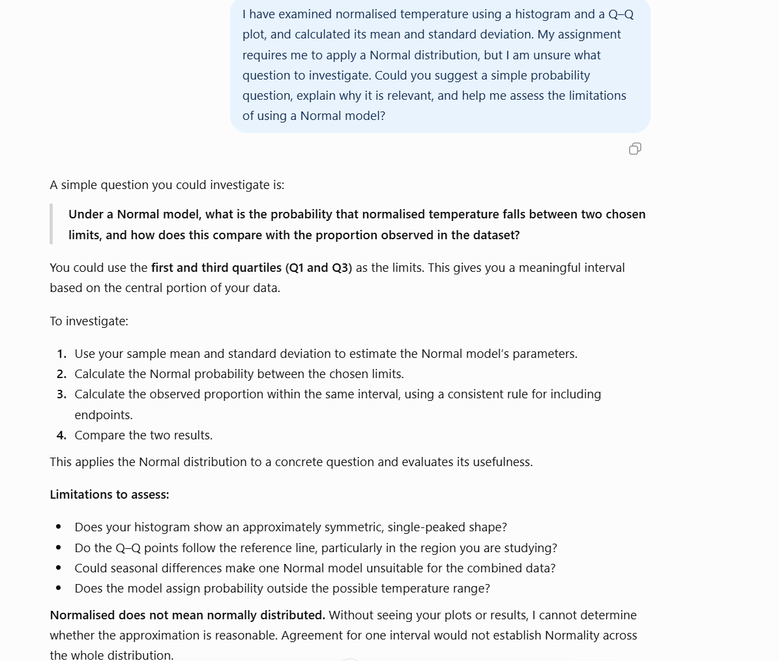
My evaluation and use:
I used the suggested question because it allowed me to apply a normal model and compare its estimated probability with the observed proportion. The comparison helped me identify limitations of the model

A6
AI Tool:ChatGPT
date: 28-10-2026
purpose: I need python code to calculate the probability between the first and third quartile under a Normal model.
Exact Prompt and Relevant Output:
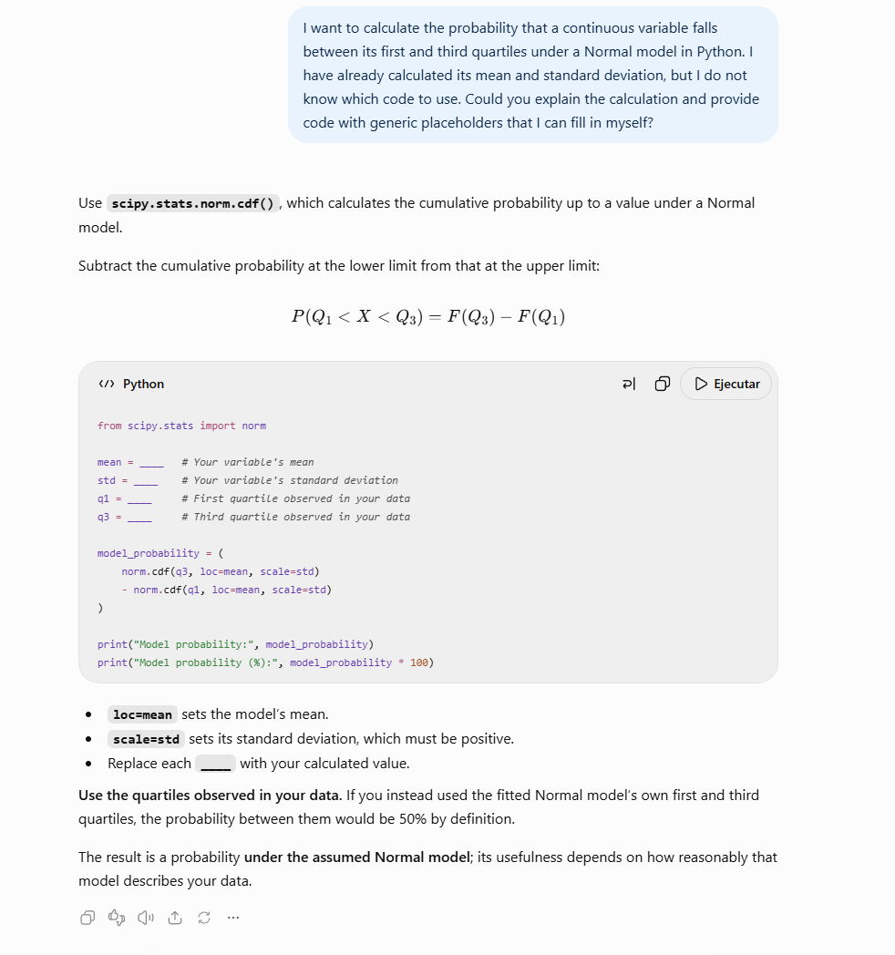
My evaluation and use:
I adapted the code using my temperature data. The explanation helped me understand how subtracting two cumulative probabilities give the probability within the chosen interval. I then compared this result with the observed proportion to assess the model’s limitations.

A7
AI Tool: ChatGPT
Date: 30-10-2026
Purpose: I need a python code to simulate 100 and 1000 poisson observations while keeping lambda constant and compare the results.
Exact Prompt and Relevant Output:
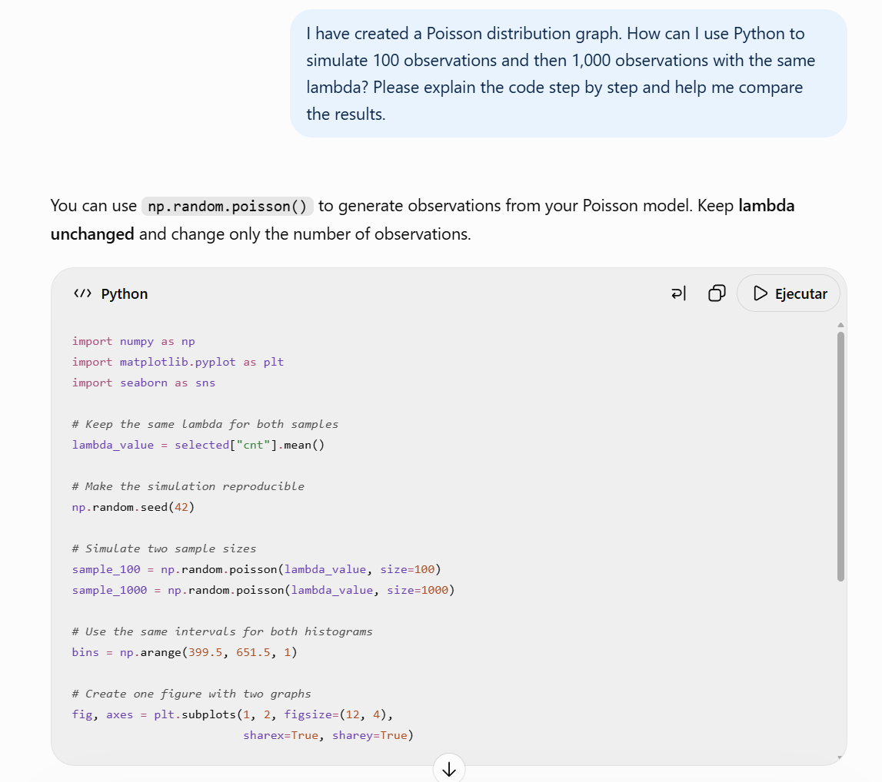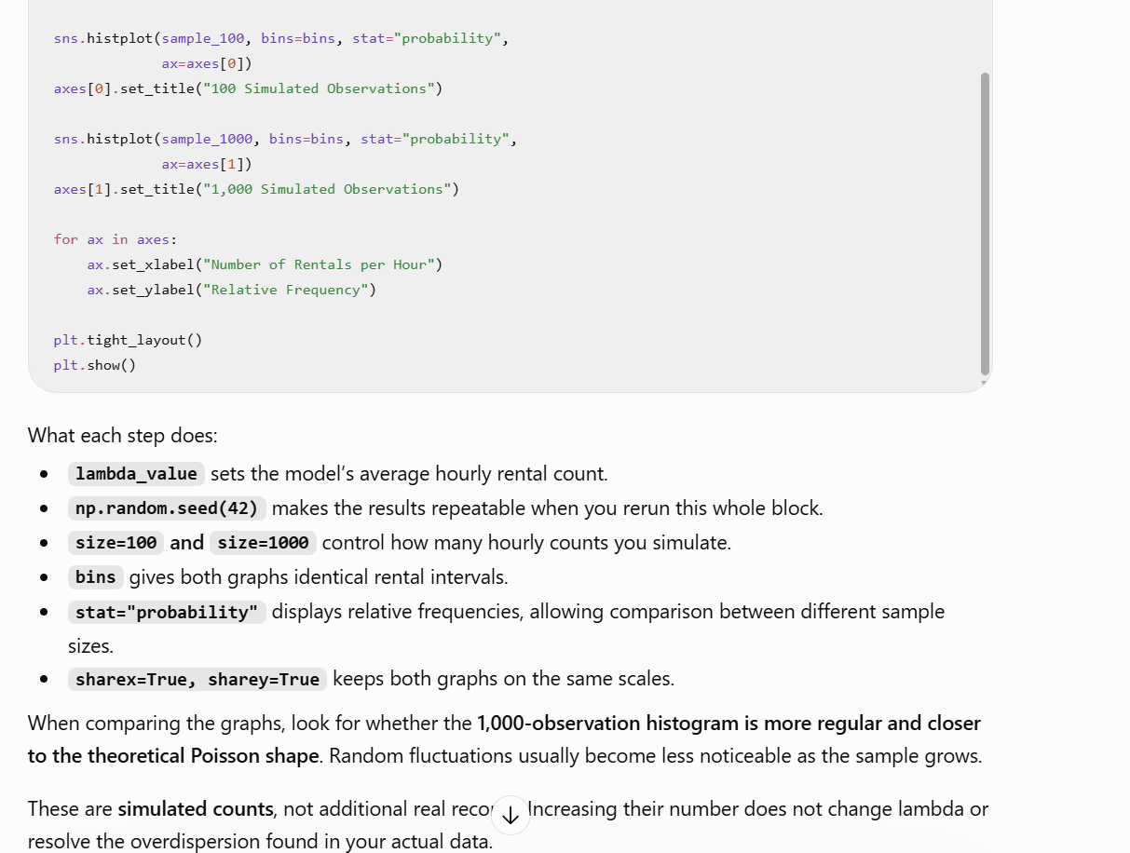
my evaluation and use:
I used the code to create and compare both histograms. This helped me understand that large samples produce more stable relative frequencies, but do not eliminate the overdispersion in the real data.

